Contact person for editorial offices:
Dirk Rott, Head of Marketing

06.03.2018/ DRO
Press release WA1802: PROFINET Heavy Duty Rotary Encoders
Images/text are approved for publication in the trade press (print and online). Please send us a specimen copy after publication. Thank you for your efforts in advance.
________________________________________________________________________
PROFINET Heavy Duty Rotary Encoders
Heavy-duty rotary encoders for PROFINET from the modular system
Wachendorff Automation has extended its WDGA absolute rotary encoder series in the PROFINET-IO field with the extremely robust WDGA 58D – designed for heavy-duty applications.
As it has already been implemented for the SSI, CAN, PROFIBUS interfaces, the shaft of PROFINET encoder WDGA 58D can be loaded both radially as well as axially with max. 400 N. This is an absolute peak value and guarantees a long service life.
Wachendorff ensures an above-average service life, especially in harsh industrial applications, by carrying out extensive environmental simulation tests during development. This is emphasised by Wachendorff with a 5-year warranty that is unique on the market.
The PROFINET WDGA rotary encoder can be used in real-time applications in IRT mode due to its 50 μs internal dynamics.
In the multiturn field, PROFINET rotary encoders are equipped with maintenance-free and space-saving EnDra® technology. The innovative singleturn range with QuattroMag® technology provides a high resolution of up to 16 bits and an accuracy of +/ 0.0878° (12 bits).
This makes it possible to use robust and durable magnetic technology from Wachendorff in many areas where previously only high-precision and sensitive optical measurement technology could be used.
With its IP67 housing, the PROFINET WDGA 58D rotary encoder can be used in demanding industrial applications where contamination, very wide temperature ranges, strong vibrations and large bearing loads play a role.
Plant and machine builders also benefit from the modular principle strictly applied by Wachendorff Automation and the LeanQ production philosophy. This makes it possible to implement customer-specific variations quickly and cost-effectively for optimum integration into the application.
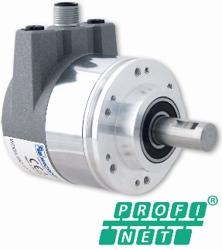
More information:
www.wachendorff-automation.com/wdga

Image (Wachendorff Automation):
WA1802_Wachendorff_Drehgeber_PROFINET_HeavyDuty.jpg

